Name _________________________________________________ Class: ______________________

NKHAMENYA CLUSTER

2020/2021 MSCE MOCK EXAMINATIONS

CHEMISTRY

Subject Number: M038/I
Tuesday, 3rd August, 2021.
Time Allowed : 2 hours; 1:30 – 3:30 pm

PAPER I
(100 marks)

Question Number | Tick if answered | Do not write in these columns
1
2
3
4
5
6
7
8
9
10
11
12
13

Instructions
- This paper contains 12 printed pages. Please check.

- This paper has two sections A and B. Answer all questions in both sections.

- Write your answers on the question paper in the spaces provided. The maximum number of marks for each question is indicated against each question. A pencil should be used for all drawings.

- Write your Examination Number at the top of each page

- In the table provided on this page, tick against the number of the question you have answered

- You should hand in your question paper to the invigilator when time is called to stop writing

© NKHAMENYA CLUSTER 2020/21 TURN OVER/
- Below is an equation representing the burning of octane C₈H₁₈.
2C₈H₁₈ +17 O₂ 16 CO + 18H₂O
- Determine the limiting reagent in the reaction if there was 60g of oxygen and 50g of octane. (4 marks)

- Calculate the mass in grammes of water produced.

- marks)
- a) What is the difference between Exothermic and Endothermic reactions
_______________________________________________________________________________________________________________________________________________________________________________________________________________________________________________________________________________________________________________________________________________(2 marks)

b) A laboratory technician dissolved Potassium nitrate in water. Study the chemical equation below and answer the questions which follows:

KNO_{3 (s)}+H₂O_{(l)} K⁺(aq) + NO₃⁻ (aq) , ∆H = 34.6Kj
- What type of reaction is demonstrated by the chemical equation
__________________________________________________ (1 mark)
- Give a reason for your answer
______________________________________________________________________________________________________________________________
(2 marks)
- Explain the effect of adding more potassium nitrate on the reactants side
__________________________________________________________________________________________________________________________________________________________________________________________________________________________________________________ (3 marks)

- Give any other two factors that can produce similar results.
____________________________________________________________________________________________________________________(2 marks)
- Below are organic compounds. Study them and answer the questions that follows:
- C₂H₄ C. CH₃COOH
- C₃H₈ D. C₂H₅ OH
- Which compounds are hydrocarbons
_______________________________________________________ (2 marks)
- Write down a balanced chemical equation for the reaction between compound A and Hydrogen (H₂)
_______________________________________________________ (3 marks)

- Explain the difference in boiling points between compound C and compound D despite having the same number of carbon atoms.
______________________________________________________________________________________________________________________________________________________________________________________________________________________________________________________________ (3 marks)
- What name is given to the reaction of compound C and compound D
________________________________________________________ (1 mark)
- a) According to lowry-bronsted theory
- Define an acid
_____________________________________________________ (1 mark)

- Complete the chemical equation below

HCl (aq) + NH₃ (aq) ________ +___________ (2 marks)

- Write down any one conjugate acid –base pair.
____________________________________________________ (2 marks)

- a. Explain how lime is used to treat soil acidity
__________________________________________________________________________________________________________________________________________________________________________________________________________________________________________________________________________(3 marks)
- Mention any two applications of precipitation reactions in everyday life
_______________________________________________________________________________________________________________________________ (2 marks)
- Figure shows structures of organic compounds
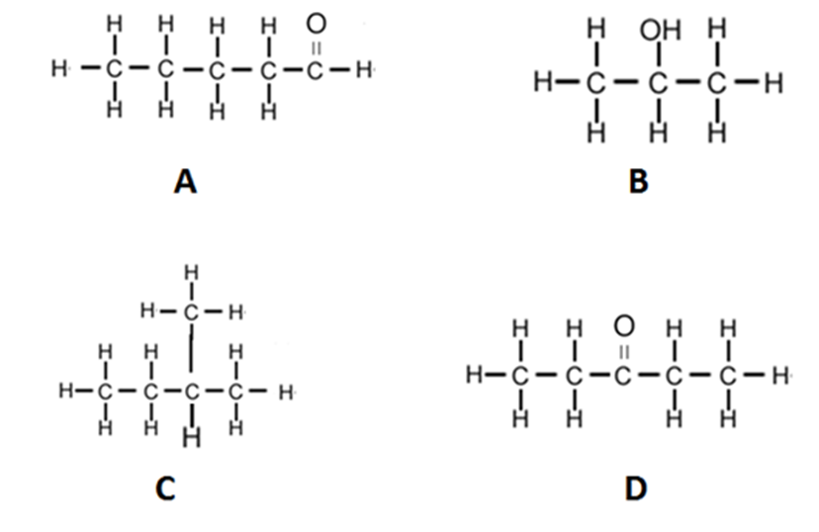
- Name the compounds A and C. (2 marks)
A_________________________________________________
C_________________________________________________
- To which homologous series does compound D belong? (1 mark)
_____________________________________________________________________
- Describe a test to distinguish A from D. (3 marks)
_____________________________________________________________________
_____________________________________________________________________
_____________________________________________________________________
- Draw any two isomers of compound A. (2 marks)

- Give any one use of compound D. (1 mark)
____________________________________________________________________
- a. i. Define oxidation in terms of hydrogen atoms
________________________________________________________________________________________________________________________________________________
(1 mark)
ii. Given that the oxidation number of oxygen is -2 (O = -2). Calculate the oxidation number of Manganese (Mn) in MnO⁻₄

(2 marks)
- Study the electrochemical cell below and answer the questions that follows

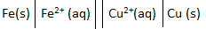

- What name is given to the two parallel lines in the cell
__________________________________________________ (1 mark)
- Mention any two uses of the part named in c (i) above
_____________________________________________________________________________________________________________ (2 marks)
- Given that Iron (Fe) has an electrode potential of -0.44 and copper (Cu) has +0.34. Calculate the electromotive force of the cell. (3marks)

- a. Table 1 below shows bond energies of some elements. Use it to answer the questions below.
Bond | Energy(kj/mol)
C-H | 413
O=O | 498
O-H | 464
C=O | 805

Methane reacts with oxygen to produce carbon dioxide and water according to the equation below.
CH_{4(g)} + 2O_{2(g)} →CO_{2(g)} + 2H₂O_{(l)}
Use the table of bond enthalpies to calculate $∆$H for the reaction (4 marks)

- Define the term Relative Atomic Mass (RAM)
________________________________________________________________________________________________________________________________(1 mark)
- Silicon (Si) consists of three isotopes: Silicon-28, 92.2%, Silicon -29, 4.7% and Silicon – 30, 3.1%. Calculate the Relative Atomic Mass (RAM) of silicon.
(3 marks)

- a. Define electronegativity
__________________________________________________________________________________________________________________________________ (1 mark)
- Mention any difference between ionic and covalent compounds
__________________________________________________________________________________________________________________________________________________________________________________________________________________________________________________________________________(2 marks)
- a. Define an alloy
__________________________________________________________________________________________________________________________________________________________________________________________________________________________________________________________________________(1 mark)
- Mention any two properties of metals
__________________________________________________________________________________________________________________________________________________________________________________________________________________________________________________________________________(2 marks)
- Explain why metals have high melting and boiling points
___________________________________________________________________________________________________________________________________________________________________________________________________________________________________________________________________________________________________________________________________________________________________________________________________________________(3 marks)

Section B (30 marks)

- a. By providing examples, describe two types of oxides.
_______________________________________________________________________________________________________________________________________________________________________________________________________________________________________________________________________________________________________________________________________________________________________________________________________________________________________________________________________________________________________________________________________________________________________________________ (4 marks)
b. Discuss three methods of preparing salts. Include relevant chemical equation for
each method you mention.
_______________________________________________________________________________________________________________________________________________________________________________________________________________________________________________________________________________________________________________________________________________________________________________________________________________________________________________________________________________________________________________________________________________________________________________________________________________________________________________________________________________________________________________________________________________________________________________________________________________________________________________________________________________________________________________________________________________________________________________________________________________________________________________________________________________________________________________________________________________________________________________________ (6 marks)
- A new brand of soap is found to cause skin irritation when used. An old brand of the same soap did not cause skin irritation. A chemist decides to compare the components of the dyes of the two brands of soap to see if they are different, describe an experiment that could be done to isolate the components of the dyes.
_____________________________________________________________________________________________________________________________________________________________________________________________________________________________________________________________________________________________________________________________________________________________________________________________________________________________________________________________________________________________________________________________________________________________________________________________________________________________________________________________________________________________________________________________________________________________________________________________________________________________________________________________________________________________________________________________________________________________________________________________________________________________________________________________________________________________________________________________________________________________________________________________________________________________________________________________________________________________________________________________________________________________________________________________________________________________________________________________________________________________________________________________________________________________________________________________________________________________________________________________________________________________________________________________________________________________________________________(10marks)

- a. Using a well-labelled diagram, describe the water cycle.

_______________________________________________________________________________________________________________________________________________________________________________________________________________________________________________________________________________________________________________________________________________________________________________________________________________________________________________________________________________________________________________________________________________________________________________________________________________________________________________________________________________________________________________________________________________________________________________________________________________________________________________________________________________________________________________________________________________________________________________________________________________________________________________________________________________________________________________________________________________________________________________________________________________________________________________________________________________________________________________________________________________________________________________________________________________________________________________________________________________________ (8 marks)

b. Describe the ‘greenhouse effect’?
_______________________________________________________________________________________________________________________________________________________________________________________________________________________________________________________________________________________________________________________________________________________________________________________________________________________________________ (2 marks)

END OF QUESTION PAPER

